1. Creating Common Visualizations
A. Bar Chart: Sales by Category
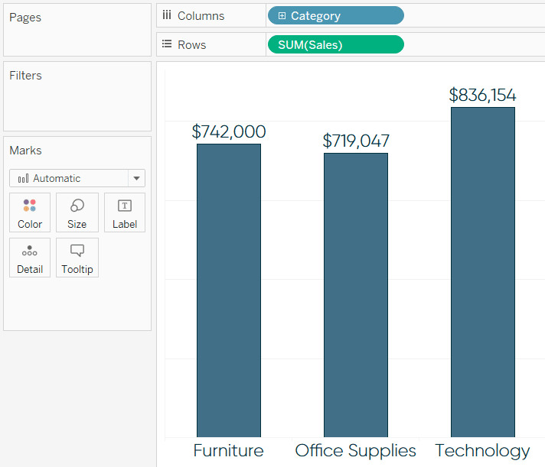
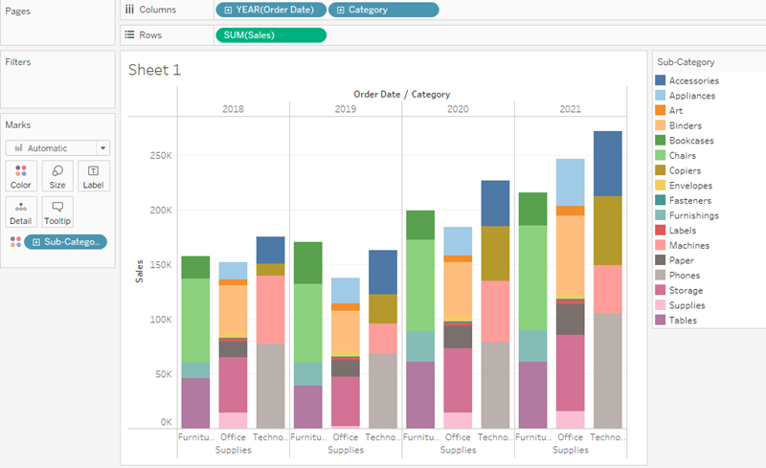
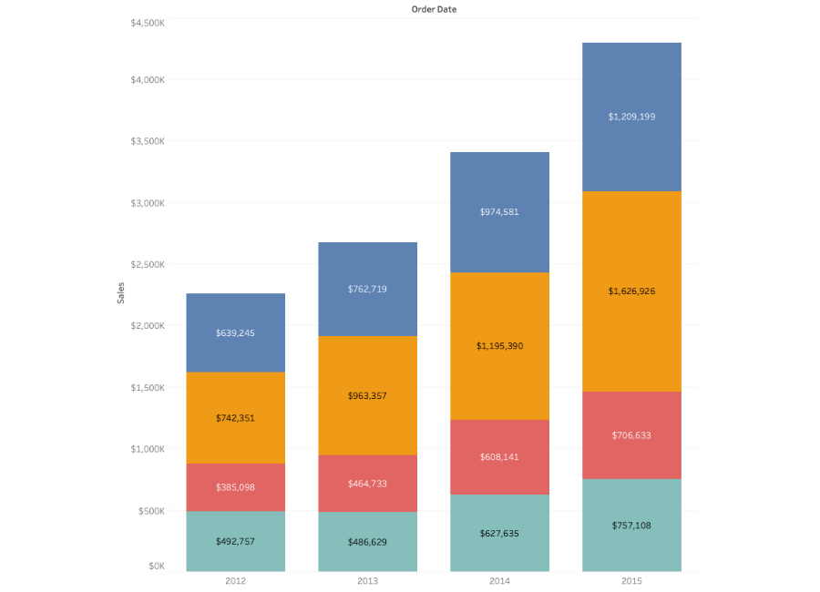
4
Steps
- Open a new worksheet.
- Drag Category to Rows.
- Drag Sales to Columns.
- Tableau creates a bar chart.
- To quickly adjust chart type, open Show Me and select Bar.

B. Line Chart: Sales Over Time
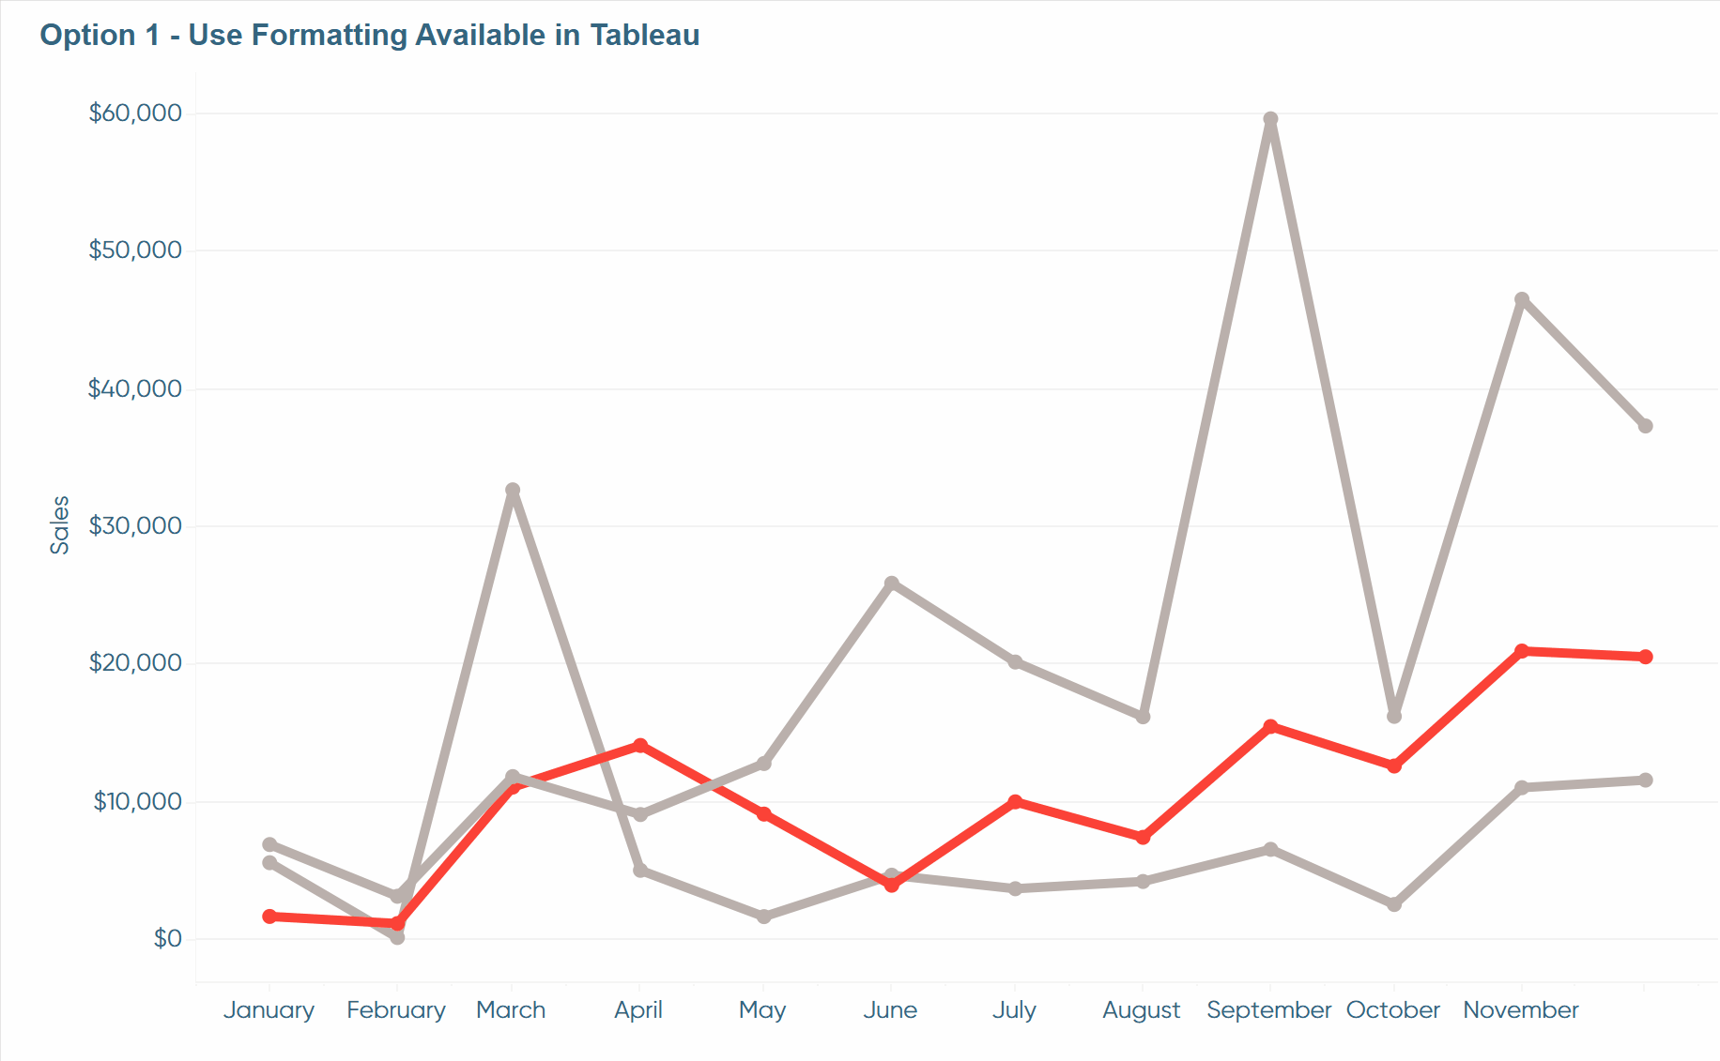
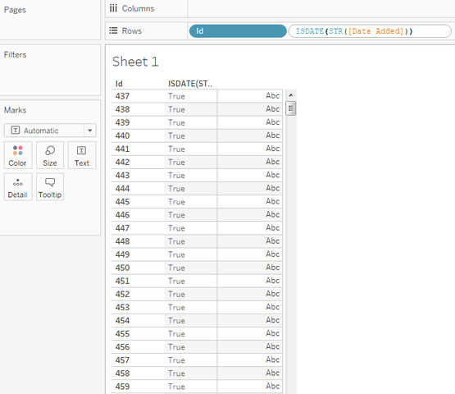
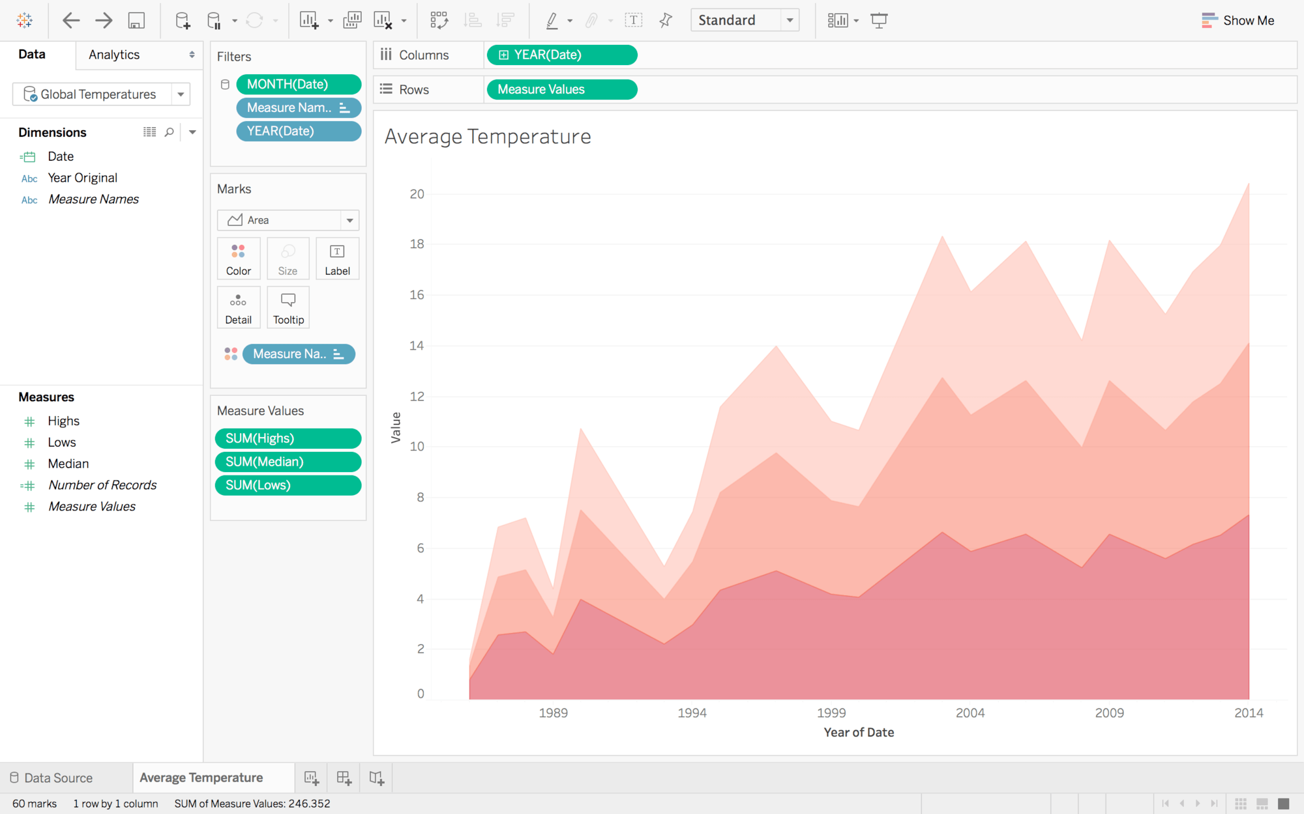
4
Steps
- Open a new worksheet.
- Drag Order Date to Columns.
- Drag Sales to Rows.
- Tableau generates a time-series line graph.
- In Marks panel, choose Line if needed.

C. Pie Chart: Profit by Region
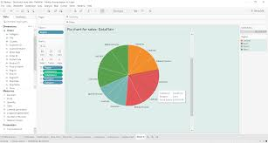
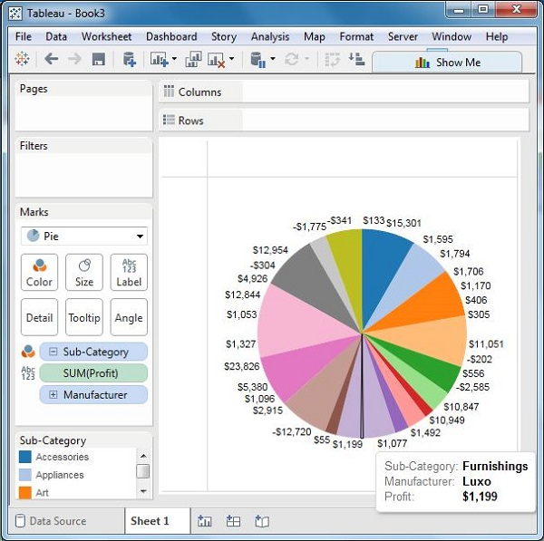
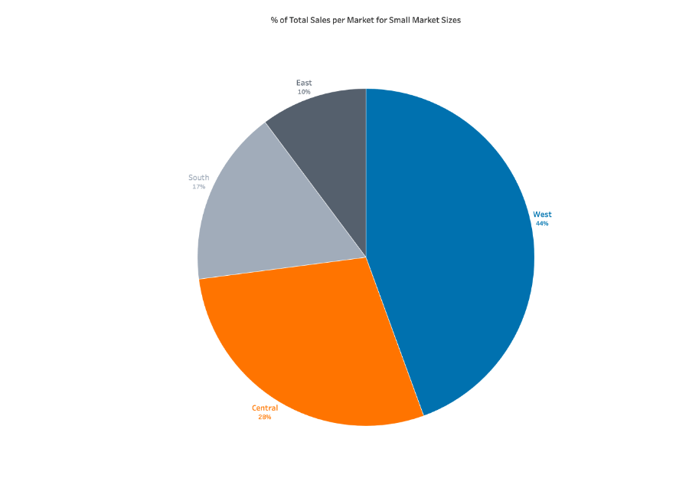
4
Steps
- Create a new worksheet.
- Drag Region to Color.
- Drag Profit to Angle (in Marks).
- Change the Marks type to Pie.

D. Scatter Plot: Sales vs Profit
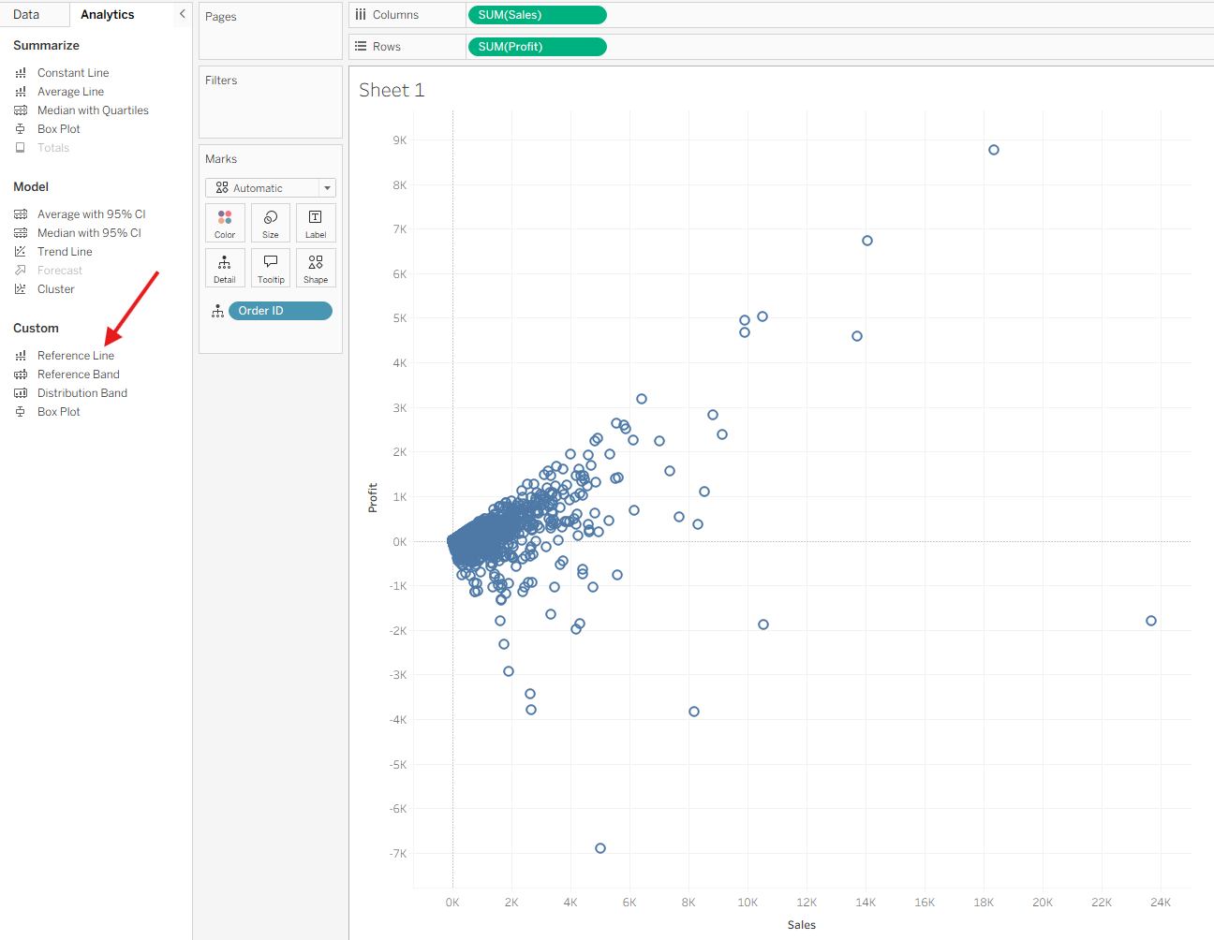
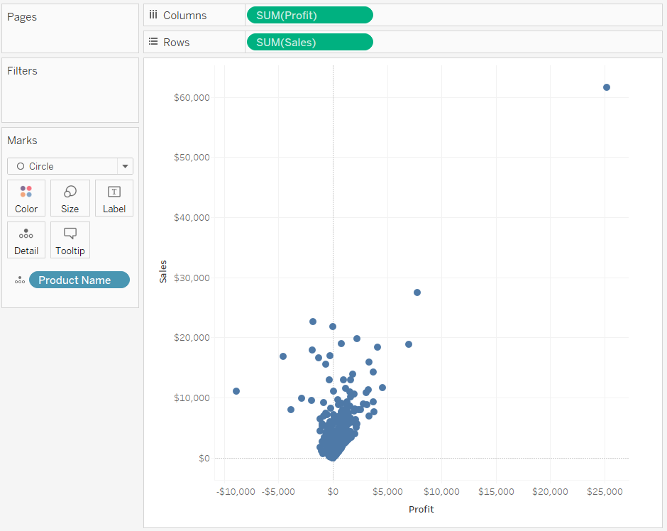
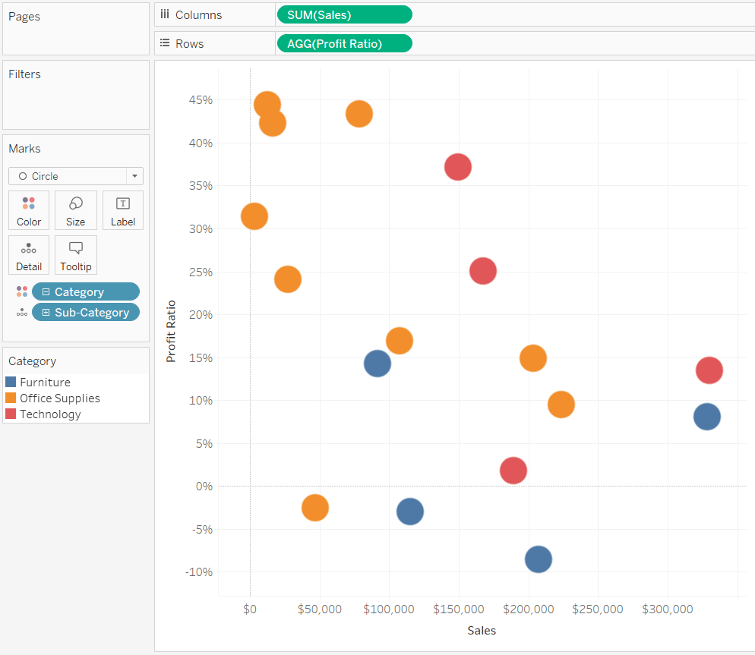
4
Steps
- New worksheet.
- Drag Sales to Columns.
- Drag Profit to Rows.
- Change Marks type to Circle.
- Add Category to Color to group points.

2. Assembling a Dashboard Layout
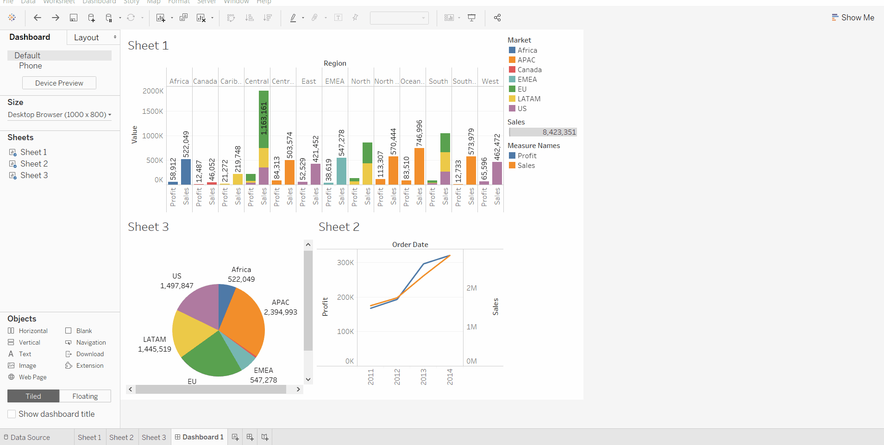
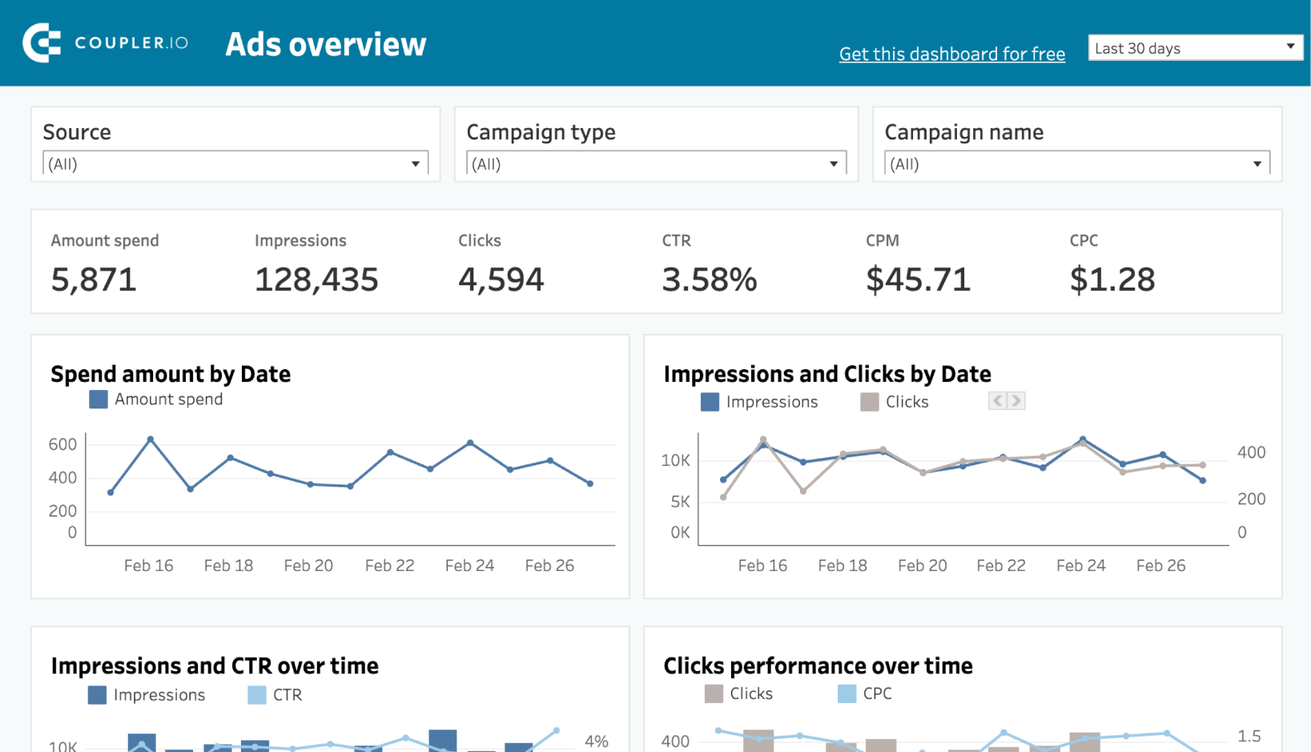
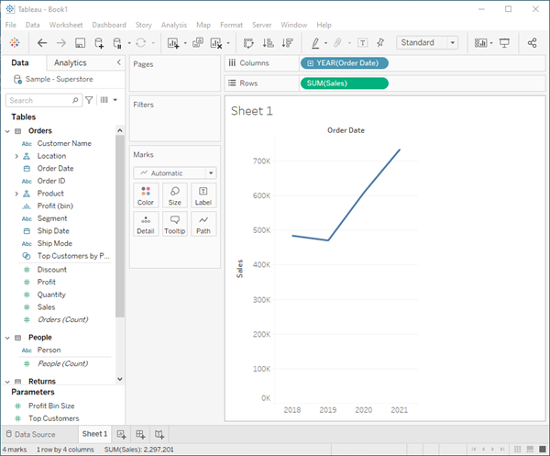
4
Steps
- Click the New Dashboard icon at the bottom (looks like a grid).
- On the left side, you will see all created sheets.
- Drag your sheets into the canvas one by one.
- Use containers (Horizontal, Vertical) to organize layout.
- Adjust each chart size using drag handles.
Tips:
- Keep charts that answer the same question together.
- Use titles that clearly explain what the viewer is seeing.

3. Using Dashboard Filters
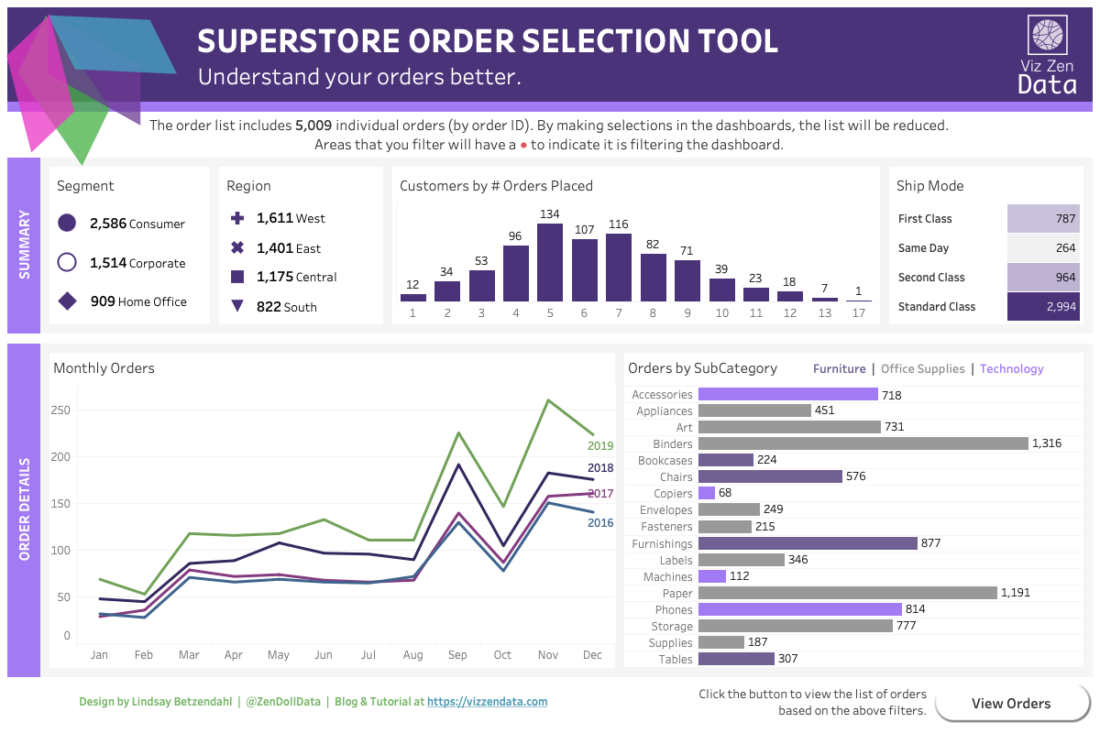
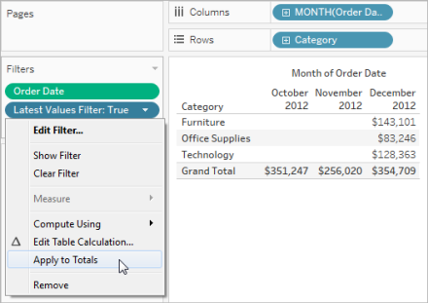
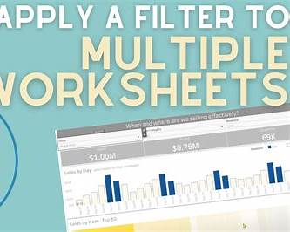
4
A. Show Filter
- Right click a chart element (like Region).
- Select Show Filter.
- A filter panel appears on the right of the dashboard.
B. Apply Filter To All Charts
- Click the filter dropdown on the dashboard card.
- Choose Apply to Worksheets.
- Select All Using This Data Source.
- Now the filter controls the entire dashboard.

